**NAME**

**COLLEGE NUMBER**

**Executive Summary**

The report contained herein is an analysis of marks of 14 students at the University du Quebec a Montreal (UQAM) handled by professor Duberri. The analysis came at a time when the Professor required the services of the firm to help home gain insights from the student grade submitted at the end of the term. The requirement is to wrangle the data and pass it through an analysis that will help the exam department get quick insights and make decisions s based on this dataset.

**Dataset description**

The dataset provided contains a row of 14 student records whose marks were obtained after conducting a series of 3 types of exams that included, assignments, midterm and final exams. All the threes exams were computed out of the possible highest score of 100. The dataset also contains a total of six variables that include:

* First name
* Last name
* Student name
* Assignment marks
* Midterm marks
* Final Exam marks

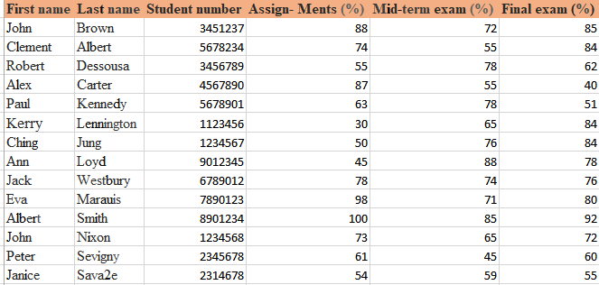

The students are uniquely identified by a student number that is not shared by any other student and can be used during analysis to retrieve their personal student information. During the analysis though, some new columns and variables shall be identified and established to solve the problems at hand.

**Aims and objectives**

The aims and objectives of this analysis are as follows:

1. To sort the student data in alphabetical order based on first name or last name values
2. To compute the weighted total for each student
3. To compute the grade band for each student
4. To computer the student grade distribution and statistical summary

**The methodology**

In order to fully meet the expected above aims and requirements, the dataset had to be wrangles by taking it through a process of cleaning,, getting any missing values, null entries or unrequired value formats in the wrong columns. The primary tool of analysis in this case is Microsoft excel tool, that acts as the primary dataset and storage of these records. During the analysis period, a number of analyses was done on the dataset that included checks on measures of central tendencies and the summary statistics. Further, certain in-built excel functions like means, averages, modes, summations were used.

Moreover, advanced data analysis on this tool were also applied like VLOOKUPS and PIVOT TABLES, the resulting data from these analyses were also used to make charts and graphical presentations. All these were targeted at meeting the required tasks as above stated in the aims and objectives of the requirements. further, the whole process is procedural and breaks down into granular parts, meaning , the analysis is done stepwise, once that particular step is concluded then the researcher can move on to the next step of the problem solution.

**Problem One: Sorting the student data in alphabetical order**

In order to solve the above problem, the data was organised and labelled correctly with the correct naming as initially required in the report. The process to active this includes the following:

* Highlighting all the columns in the student data
* Going to the data tab in ether excel navigation window
* Click sort under sort and filter
* The select sort by First name in the drop down
* The result is the sorted student list by first name

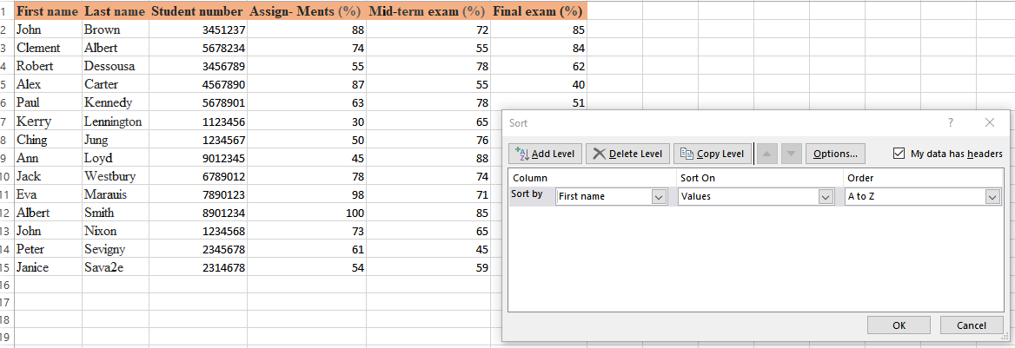

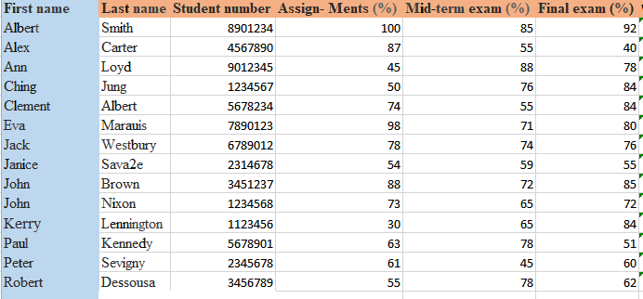

**Problem two: Compute the weighted total for each student marks per test**

To achieve this the sum values of each student have to embed across the columns of the three exams i.e assignment, midterm and the final exam. To do this, the following process was followed:

* Insert a new column next to the exam column
* Give the column a name e.g. assignment weighted score, midterm weighted score
* Inside a cell in the created column, insert the function that will take the exam percentage value and multiply by the exam e.g. for assignment it will be for example =91*0.20
* Drag the values across the assignments, midterm and final exam columns down to fill other row values
* The result is the marks for the each exam
* Drag this formula in the first cell to all the other parts of the student marks

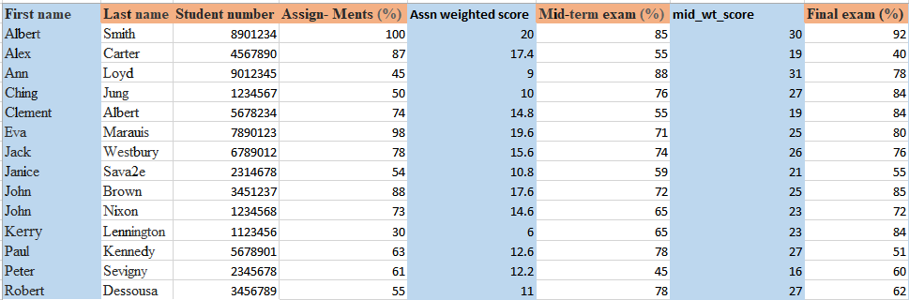

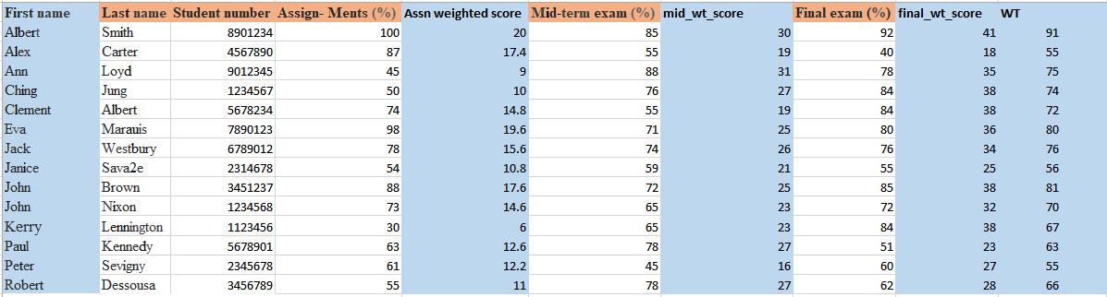

**Problem three: Compute the grade for each student**

To achieve this requirement, a new column had to be inserted next to the weighted total marks for each student, this was achieved as per below:

* Insert a new column next to the column name labelled weighted total
* Stand on the new cell position and insert the formula to get the student grades, here, enter average mark for all the students had to be established by using the formula:

=AVERAGE(E2+G2+I2)

The above formula takes the average of the student marks across the three exams and computes the resultant value to the new cell.

* The new cell value is then dragged down across the other values to achieve the averages for the other students, the result is shown below:

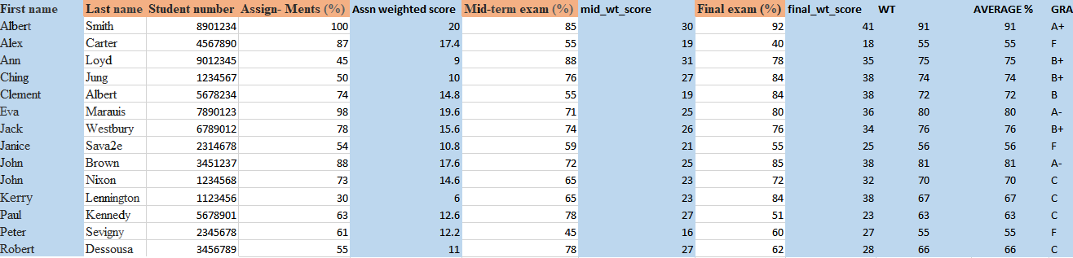

* The next step is to add a new column on next to the average percentage and give it a name, in this context, the name is grade , standing on the first cell in the newly created column, a new function, with NESTED IF conditional statements is inserted to produce the grade of each mark as per below:

*=IF(H2>=90,"A+",IF(H2>=85,"A",IF(H2>=80,"A-",IF(H2>=77,"B+",IF(H2>=73,"B+",IF(H2>=70,"B",IF(H2>=70,"B-",IF(H2>=60,"C",IF(H2<60,"F")))))))))*

The result is as shown below:

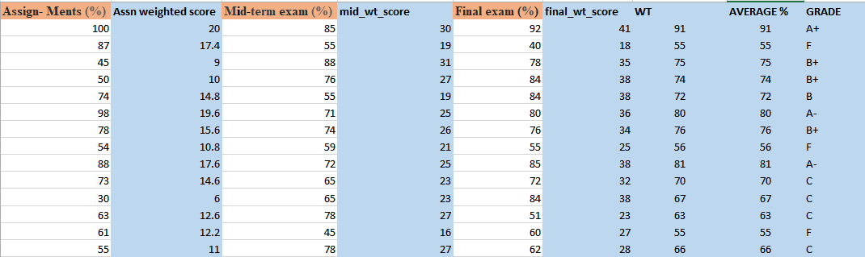

**Problem four: statistical distribution of each student grade:**

To achieve this , a new column called student grade bands so established and then a new function that reads from the next tables containing the grade band is inserted and then read across using the excel VLOOKUP function to read this data into the newly created column list for grade bands; the result is as follows :

*=VLOOKUP ($H$2:$H$15,grades_bands!$A$2:$B$45,2,0)*

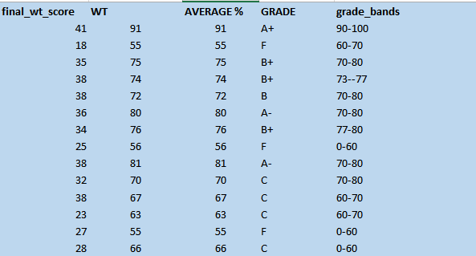

**Data presentations**

A summary presentation of this data was also visualised to reveal some of the quickest trends. For instance, the analysis of the top student’s ordered against their weighted marks revealed the following data. It can be observed that Albert and Eva were leading at the front while Janis and Peter came at the last.

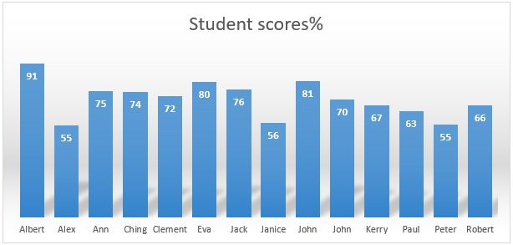

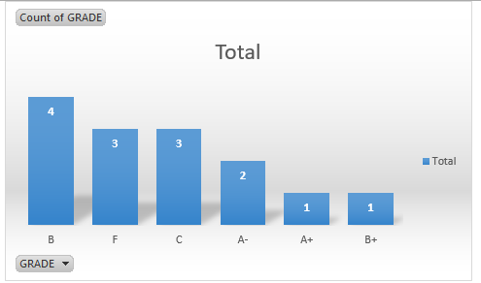

Further, analysis of the groupings by grades revealed the grade B had the highest number of students while grade B+ only had 1 student. In terms of marks and rankings of all students, again it can be observed that Albert, Eva and John scored the highest marks